# Recommendations for the Rideau Institute Website

## Home and default layout

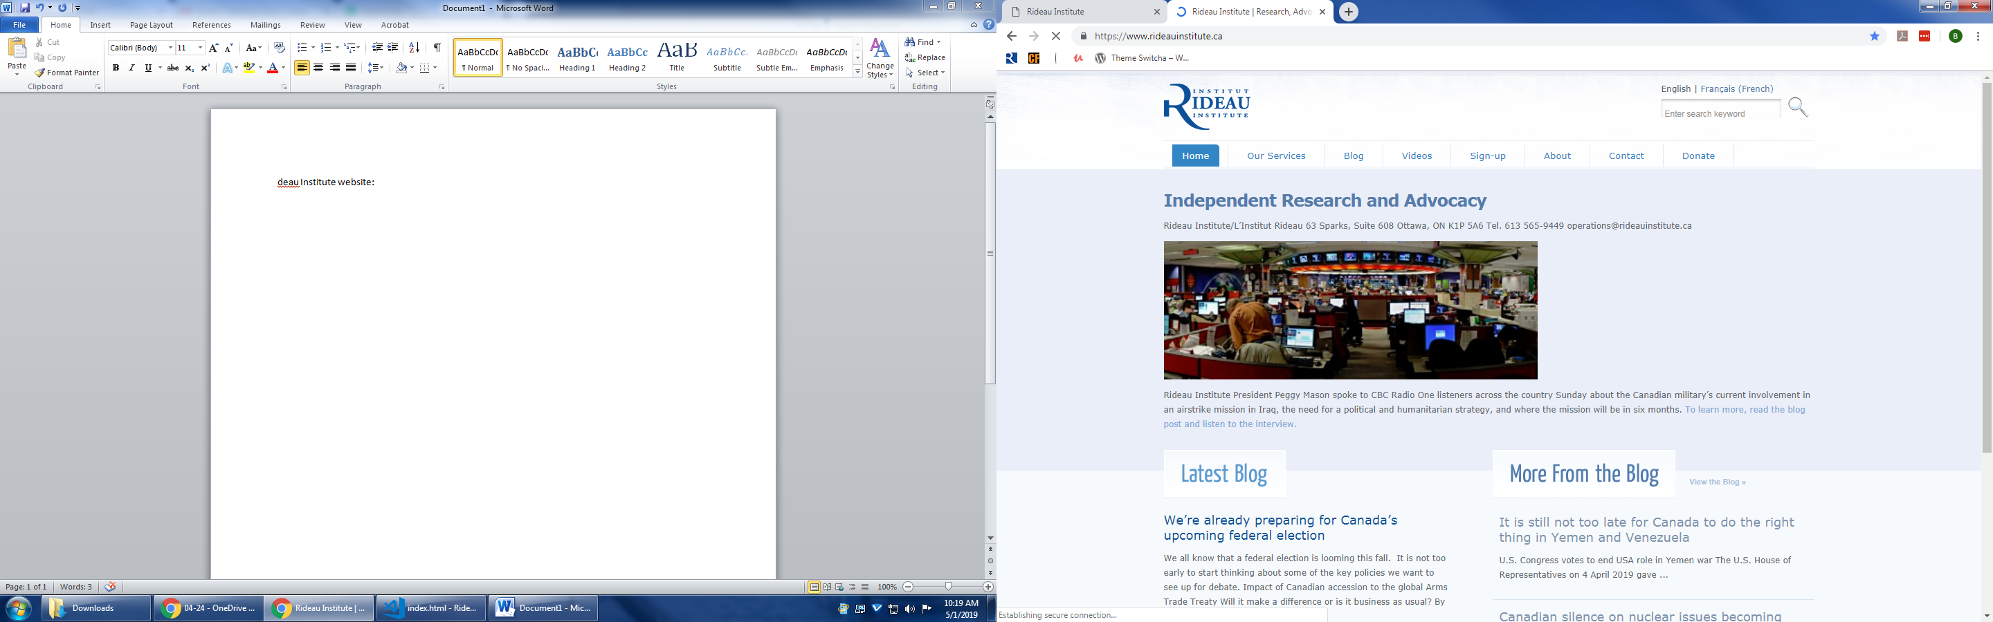

1. Too much space around the page

2. The menu has inconsistent formatting, and it should be more visible

3. The about page has unnecessary sublevels, maybe consolidate them or split a few things in a new session

1. About: add the information from “gala” to the bottom and update award that have been given since 2010
2. Peggy please edit/review the following:

**About:**

* + The Rideau Institute was founded in October of 2006 (federally incorporated as the Rideau Institute on International Affairs) and commenced operations in January 2007. It is a registered non-profit organization, and is located in Ottawa on the historic Sparks Street Mall, one block from Parliament Hill. Its modest offices are in the Hope Building overlooking the Langevin Block, the home of the Prime Minister’s Office (PMO).
  + The Institute’s primary activities are independent research, advocacy and social engagement. It aids decision makers, opinion leaders, and the public through research, analysis and commentary on foreign and defence policy.

**Mission Statement**

* + Our mission is to help restore Canada to its former peacekeeping, peacemaking and peacebuilding role in the world, through creative and innovative multilateralism, strengthening the UN and building international law.
  + The Rideau Institute conducts research and provides analysis to decision makers, opinion leaders, and the public to assist them to knowledgeably participate in the national debate on foreign, defence and national security policy. Further, it advocates for independent policy priorities that enjoy broad public support and are consistent with fundamental Canadian values.

**Sources of Funding**

* + The Rideau Institute utilizes two types of funding to achieve its objectives: individual donations and special project funding.
  + Individual and Organizational Donations
  + More than a thousand Canadians make donations to the Rideau Institute and its affiliated programs, such as the Rideau Institute Research Fund (a charitable fund registered with Tides Canada), Ceasefire.ca and its 20,000 peace supporters, and RightOnCanada.ca and its 15,000 supporters interested in promoting human rights.
  + Both Ceasefire.ca and RightOnCanada.ca are community outreach and organizing projects that primarily use the Internet to facilitate public education and advocacy on contemporary policy issues. Because of the programs’ advocacy role, contributions are not tax deductible under Canada’s tax laws.

**Special Projects Funding**

* + The Rideau Institute occasionally receives funding for specific projects, often from a single institution or foundation. These projects can range from a single conference to a multi-year educational project. The project is conducted under the auspices of the Rideau Institute, or through a collaboration between the Rideau Institute and the funding institution. The Rideau Institute does not receive project funding from any level of government.

1. Our Team will become a section in the top bar consolidating, President/Staff and directors/advisors
2. Internship will become a section in the top bar
   * Peggy please provide updated content:

**Progressive Policy Internships**

The Rideau Institute provides opportunities for students and recent graduates who want to gain hands-on experience in a non-governmental organization with a focus on foreign and defence policy. Our mission is to help restore Canada to its former peacekeeping, peacemaking and peacebuilding role in the world, through creative and innovative multilateralism, strengthening the UN and building international law.

At all times, the Rideau Institute has unpaid positions for several volunteers and interns from accredited institutions. Each academic term and in the summer months, we typically have one full-time “anchor” intern (four or five days per week) who is receiving course credit for the internship. In addition, we would also have two or three interns working at least two days per week. Volunteers typically contribute on an “as required” basis or may dedicate one day per week to specific administrative and donor-related activities.

The Institute blends research and analysis with media and Internet communications techniques as it advances its policy agenda for Canada. Officially, the Rideau Institute is a non-partisan, independent research, advocacy and consulting group in Ottawa. Unofficially, it is known as one of the most active and influential progressive policy-focused organizations in town.

Typically, the Institute will be busy with its extremely active social engagement program of social media posts and website blogs. Another key activity is preparing the regular email campaigns to engage its 50,000 supporters. In addition the President will be launching reports commissioned by the Rideau Institute, speaking at, and participating in, conferences and roundtables, engagingwith the media through articles and interviews, interacting with members of parliament and policy makers, and working with other likeminded non-government organizations to advance our progressive policy agenda.Peggy Mason, the Institute’s president, describes the experience like this: “We are a small, tightly knit organization, and while it can become energetic – even a bit frenetic at times – it is an exciting workspace where everyone helps out when needed. We want our interns and volunteers to be ready to join in as we work to make a better Canada.”

To inquire about volunteer or internship opportunities, please send a letter of inquiry and résumé to operations@rideauinstitute.ca, or call 613 565-9449.

Past Sponsors of Rideau Institute Progressive Policy Internships

Thank you to our generous sponsors who fund individual interns. Their sponsorship fosters the training, education and motivation for the next generation of Canada’s leaders and policymakers:

Communication, Energy and Paperworkers Union of Canada

Canadian Union of Public Employees National

Patricia Hartnagel

4. The Donate button should be highlighted, perhaps a bright/different colour

5. The French page gives a 404 error (Sarah suggests deleting this), and the Search box has a persistent text (it should erase it when I type it)

6. The showcase image is not in the right size; the title and the captions are outdated; the contact info should be at the bottom of the page; the link goes to an outdated 2014 article

* Update and change to latest blog post

7. More images on the blog roll. Evaluate the focus of the section and if it is necessary to have it on all pages

* Reducing redundancy of Blog and updating information, please see proposal at the bottom for updated home page

8. Add bottom part with subscription field, contact, some info, Social media etc.

9. Add a publications section for the institute studies

## Our services

Just three lines of text, maybe add to the about section.

* **Delete (From Sarah)**

## Blog

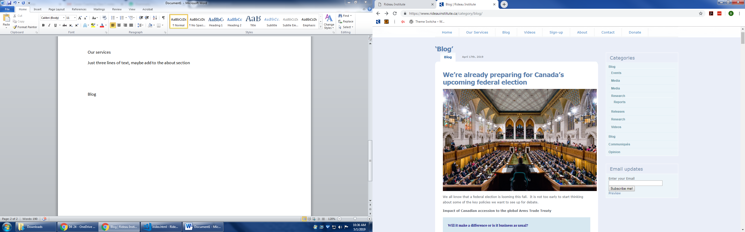

1. It has ‘blog’ written too many times, redundant

2. Change the date place and formatting

3. Maybe putting only the thumbnail and the lead of the article instead of the whole text, make it clickable for the full content

4. Inconsistent formatting on the sidebar, inconsistent sublevels and duplicate information – Need to talk to Peggy re: side bar removal and reorganization of content.

5. The preview goes to an error page **(Remove Sarah Bowles)**



6. The page is too long due to full text, links to older articles are tiny at the bottom of the page

7. Social media options should be at the top of the article

## Sign-up

Evaluate the need for the signup page. Maybe it is better to put on another part on the front page and have it on the bottom of every page.

* I think it should go at the bottom of the pages, and under the main blog on home page (Sarah)

## About

Maybe split them into 2: one for the services/history/mission statement and another one for staff, directors and internship information (or put the internship info in a 3rd page).

## Contact

Add at the bottom of every page and in the about us page.

## Donate

Add online option like ceasefire.ca.

* Yes update layout and right now and Iwill work on getting the information on how to replicate the creasefire.ca donation page.

## Publications/Videos/Events

Add a section for the pdf files, the videos and the events, but not like an article, instead put thumbnails and make it clickable. It will open on another page.

# Proposed Layout

